**3.Clip dance_sing_swing**

**1.Preparation**

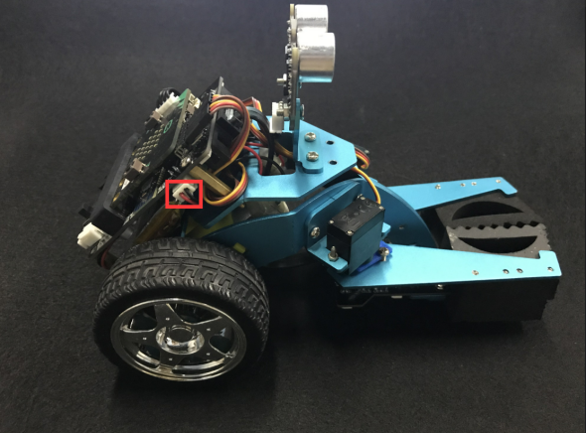 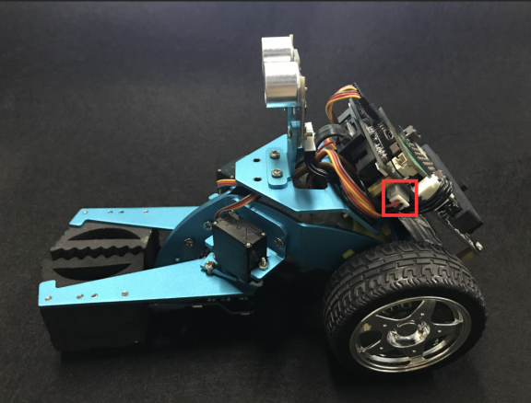

(a)Left motor on the hellobot (b)Right motor on the hellobot

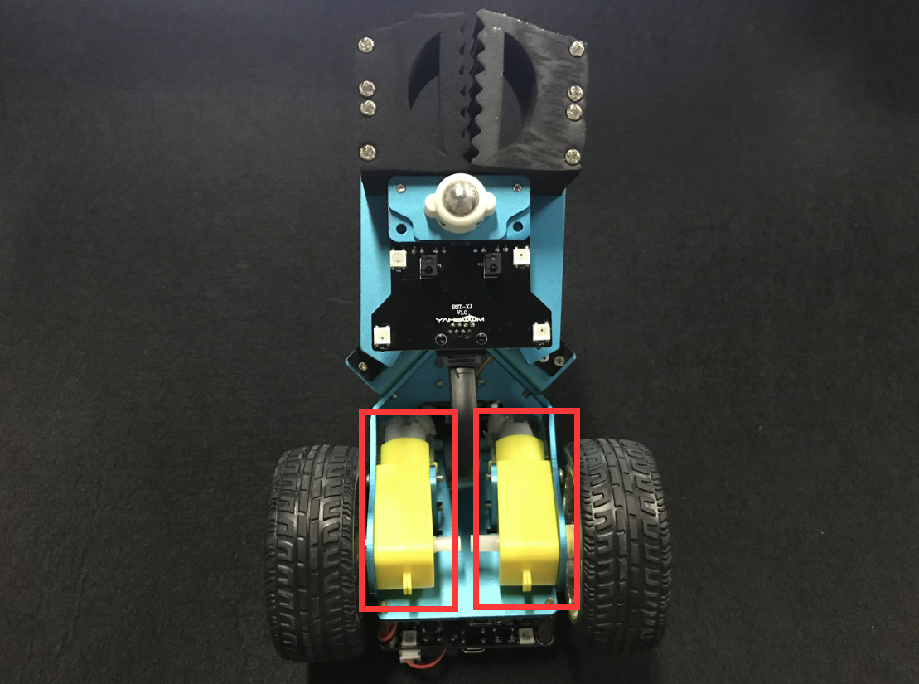

3-1 tow motors

The HelloBot robot uses two yellow TT DC gear motors, and the rotation of the motor drives the wheel forward. The motor on the left is connected to the left side of the expansion board, and the motor on the right is connected to the right side of the expansion board.

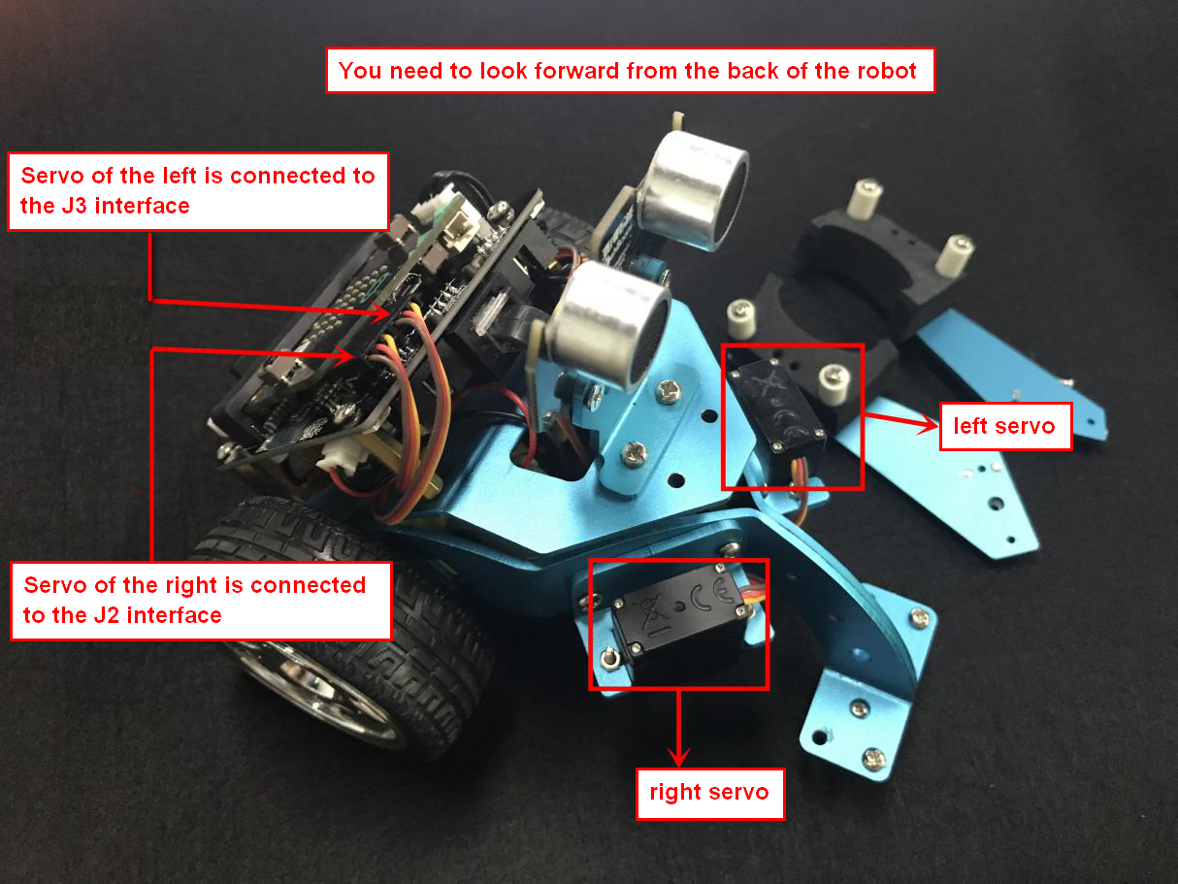

3-2 position of servo

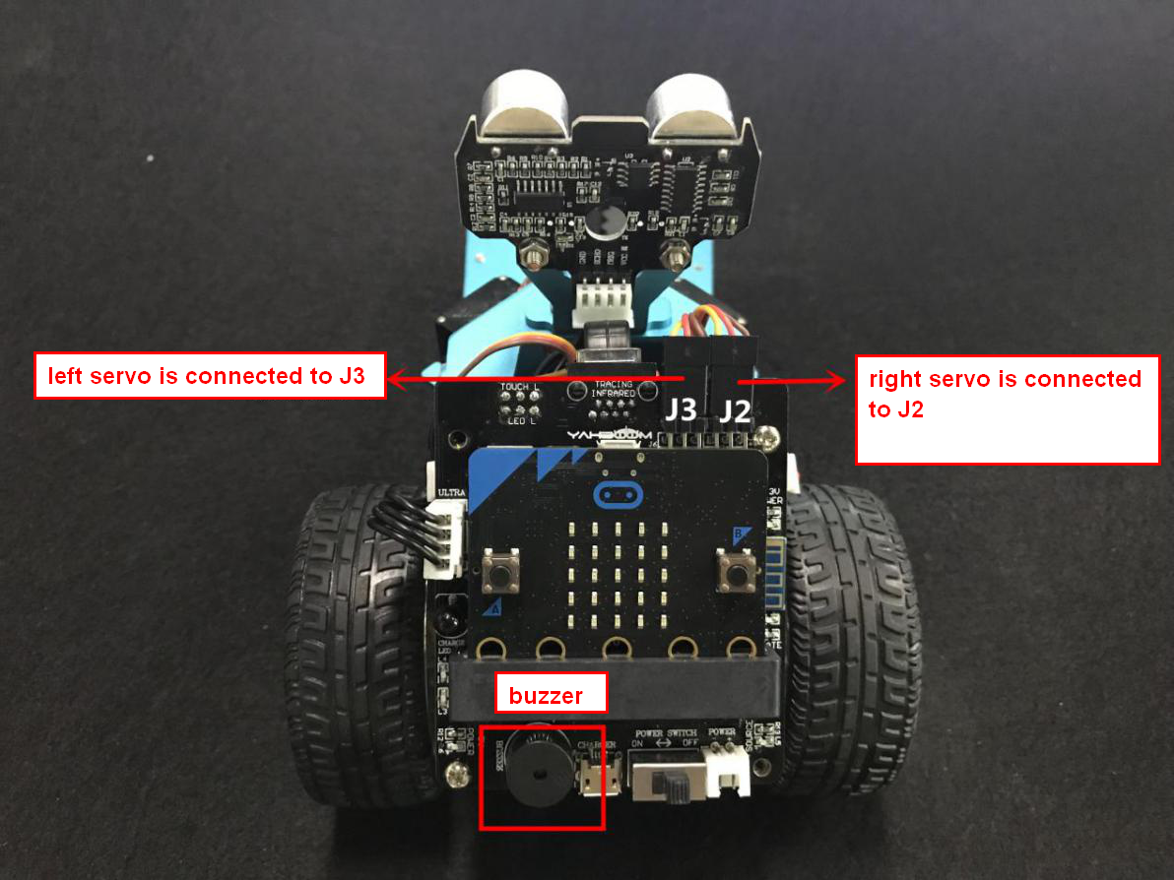

3-3 Servo interface and Buzzer

You need to connect the wiring of the servo to the expansion board, and the servo of the right is connected to the J2 interface, and the servo of the left is connected to the J3 interface. The brown line of the servo corresponds to GND, the red line corresponds to VCC, and the yellow line corresponds to IO.

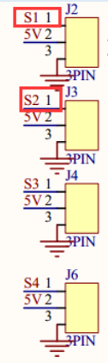

3-4 schematic of servo

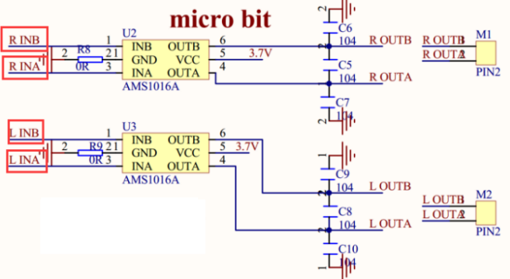

3-5 schematic of motor drive

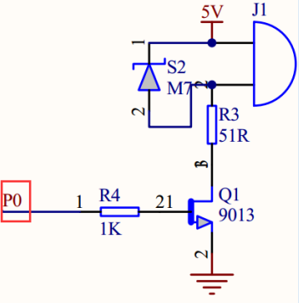

3-6 schematic of buzzer

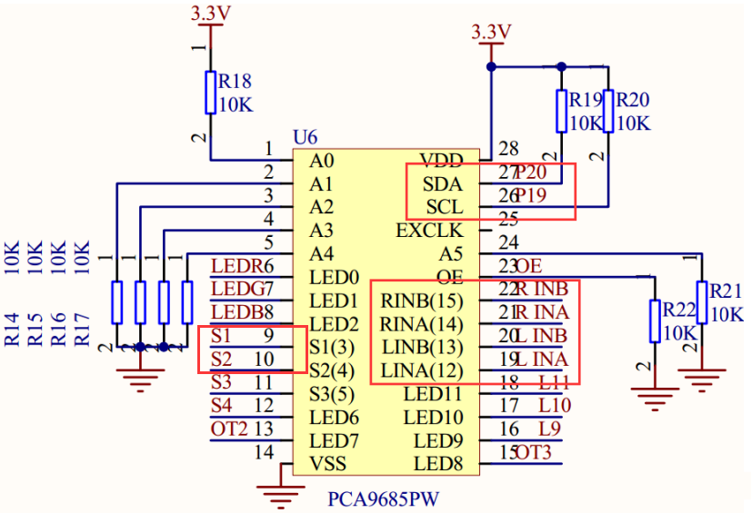

3-7 schematic of PCA9685PW

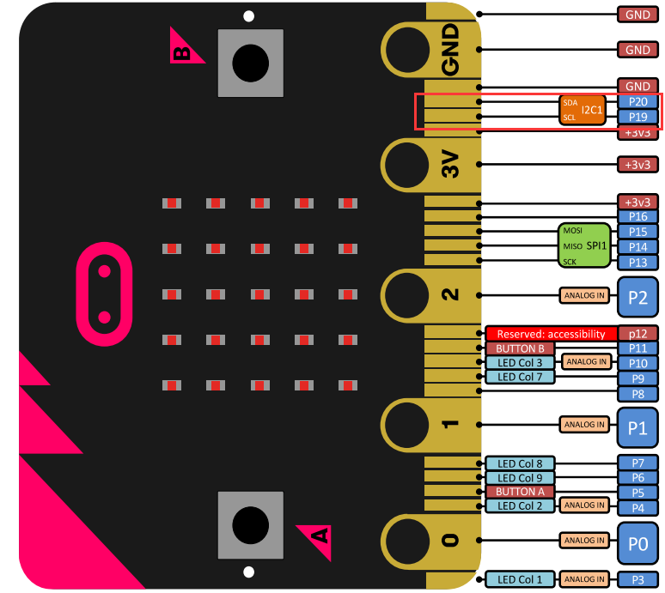

3-8  Pins of Micro:bit

From the schematic diagram. You can see that tow motors is connected to LINA(12)、LINB(13)、RINA(14)、RINB(15) of PCA9685PW.

PCA9685PW is a 16-bit LED controller with IIC bus interface. Each LED can output 12-bit resolution (4096 levels) fixed-frequency independent PWM.

1. **Learning goals**

In this course, we will learn how to make HelloBot robot advance, back, turn left, turn right, clamp swing, sing, lights.

**3.Programming**

3.1 Programming online

**1) You should use the USB cable to connect the micro:bit to the computer, at this point, the computer will have a micro:bit U disk. You need to open it, click micro:bit website, then entered the micro:bit website** or you can enter the URL directly in your browser: http://microbit.org/

2) After entering the programming interface, you need to click Add package and copy the HelloBot package URL: https://github.com/lzty634158/HelloBot to the input field, click to confirm the add package. Then you can use the blocks of the HelloBot package.

3.2 Programming offline

1) You can double-click to use it. As shown in the following figure.

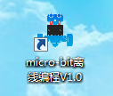

2) After entering the programming interface, you need to click Add package and copy the HelloBot package URL: https://github.com/lzty634158/HelloBot to the input field, click to confirm the add package. Then you can use the blocks of the HelloBot package.

Note: The package only needs to be added once. If you have added packages in the previous lessons, this course does not need to be added repeatedly.

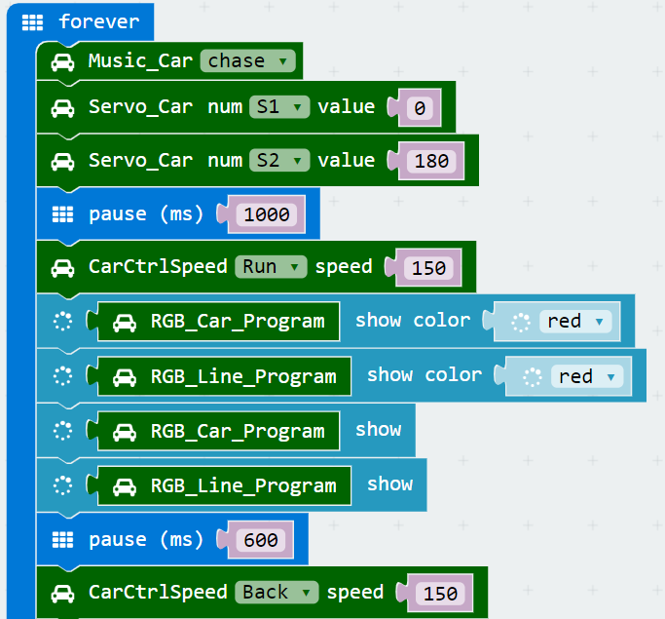

(a)

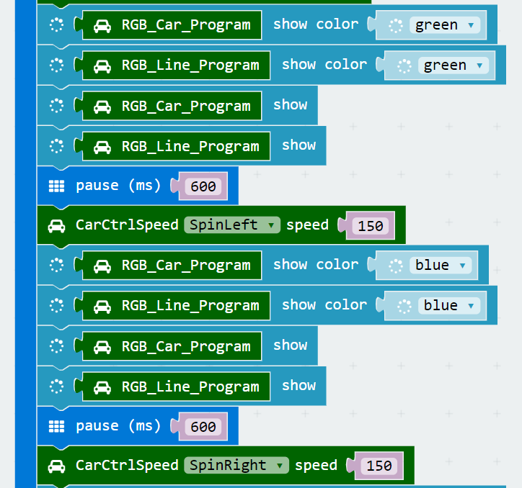

(b)

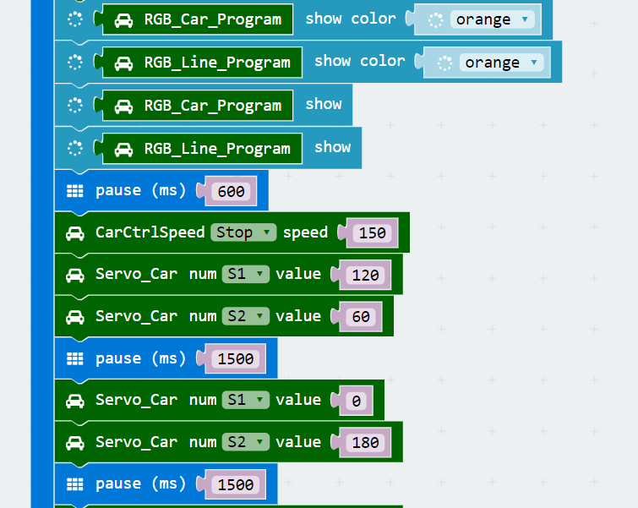

(c)

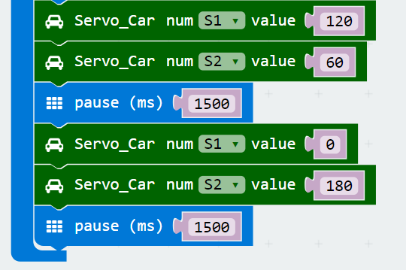

(d)

3-9 total program

The locations of blocks in the total program are shown in the following figure.

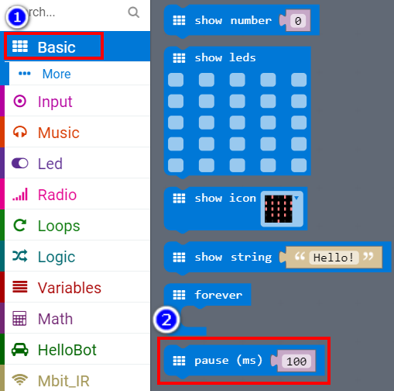

3-10

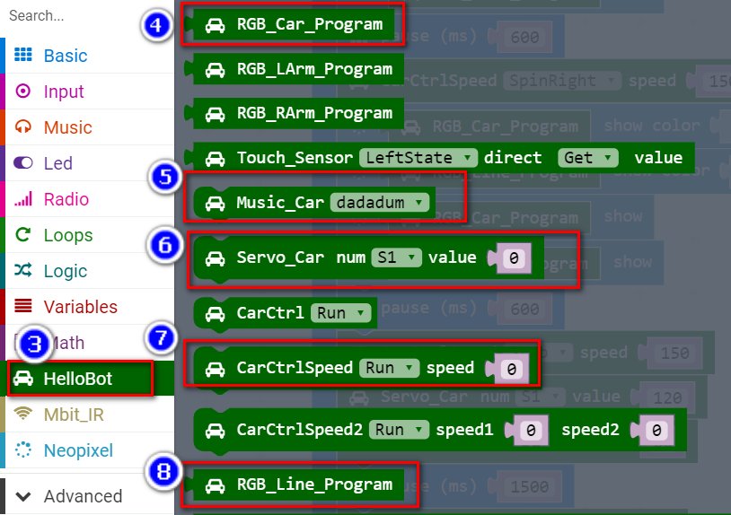

3-11

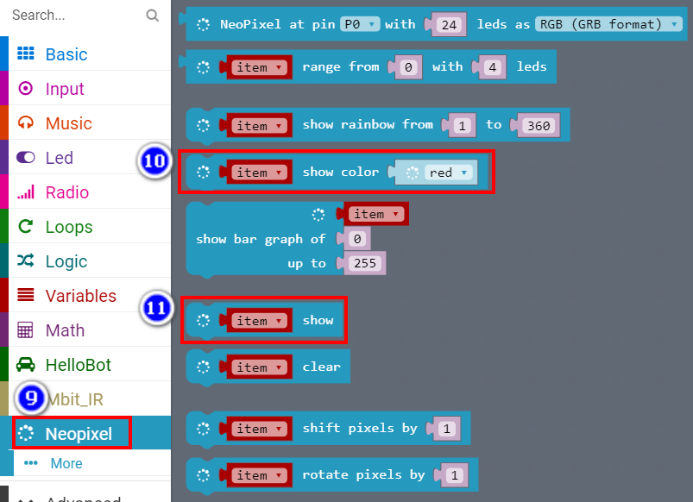

3-12

**4.Download programming**

You need to make sure that the micro:bit development board is connected to the computer. Then you should click on the download in the lower left corner as shown in 3-13 to download the program to micro:bit.

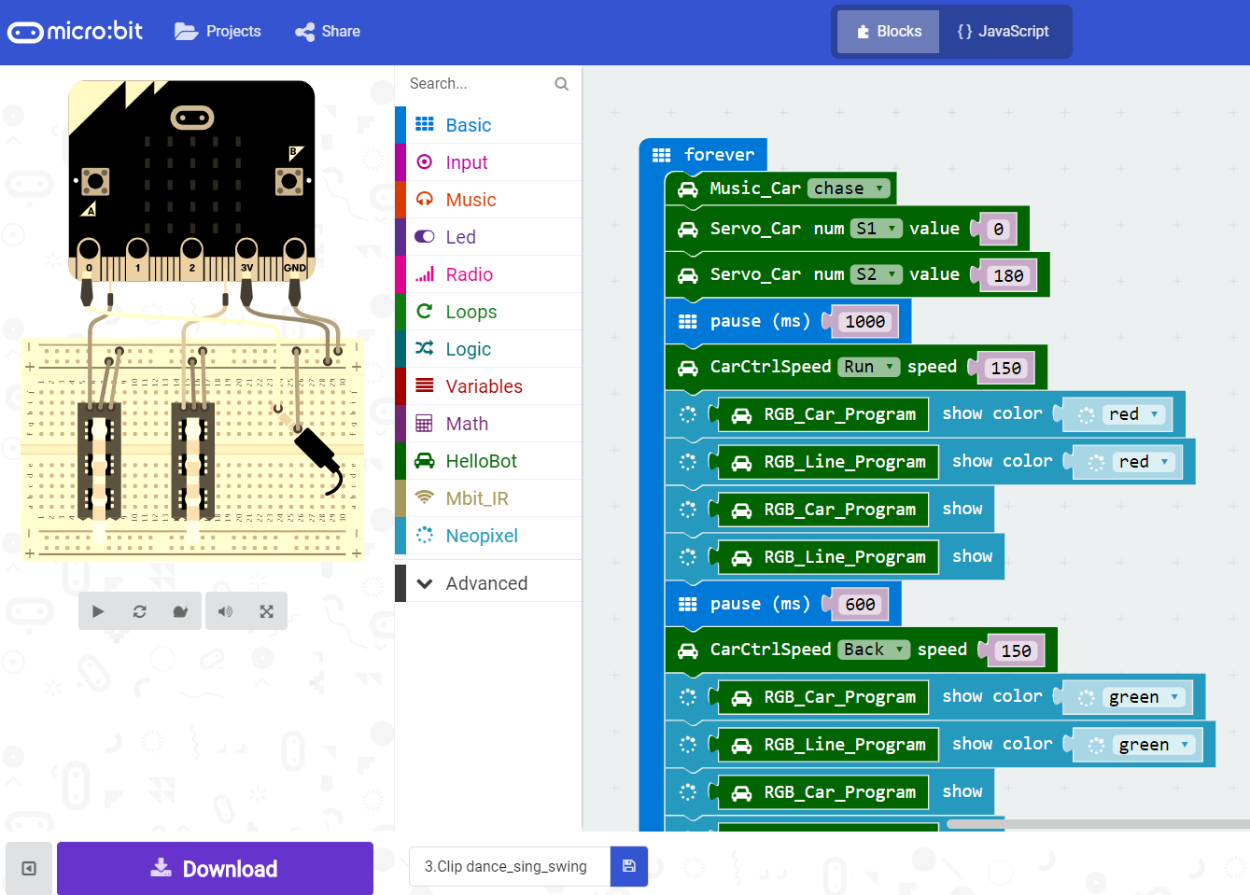

3-13

**5.Phenomenon**

After the code is uploaded. HelloBot start to play music, and advance, back, turn left, turn right,clamp swing.

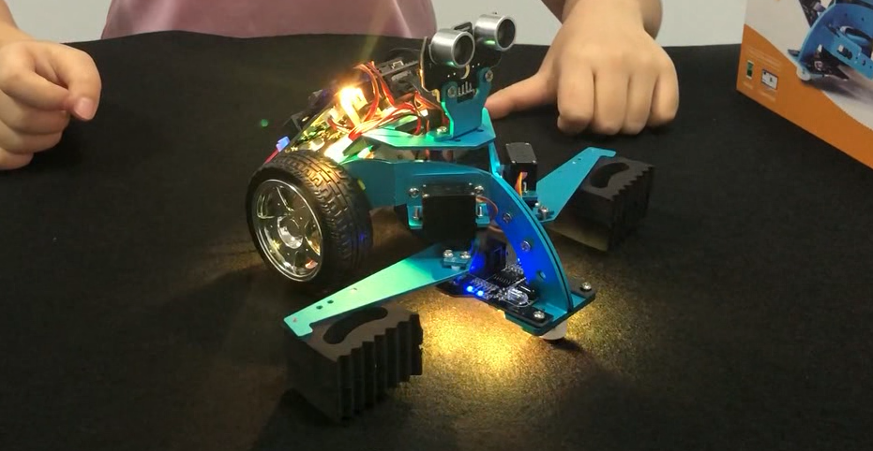

3-14